Maps & connectivity layout can be like this (Use google maps):

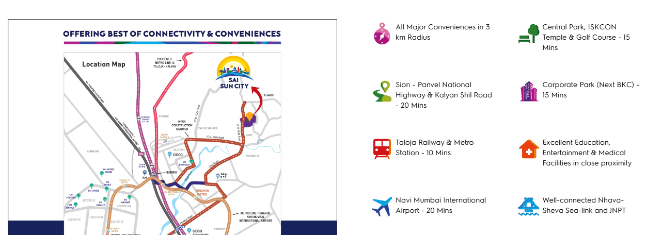

Gallery Layout:

<https://www.excellaa.com/Excellaa-Virtu/google/?gad_source=1&gad_campaignid=22332195031&gbraid=0AAAAA-_YW7d9AFkhXgaX9nq2ZXBzruG3k&gclid=CjwKCAjw24vBBhABEiwANFG7y1aZ3fZSfLZRxHZd77ld6nukNiDzfgaROnAXHEtnXoCHUoTQXUa5KhoCJPUQAvD_BwE>

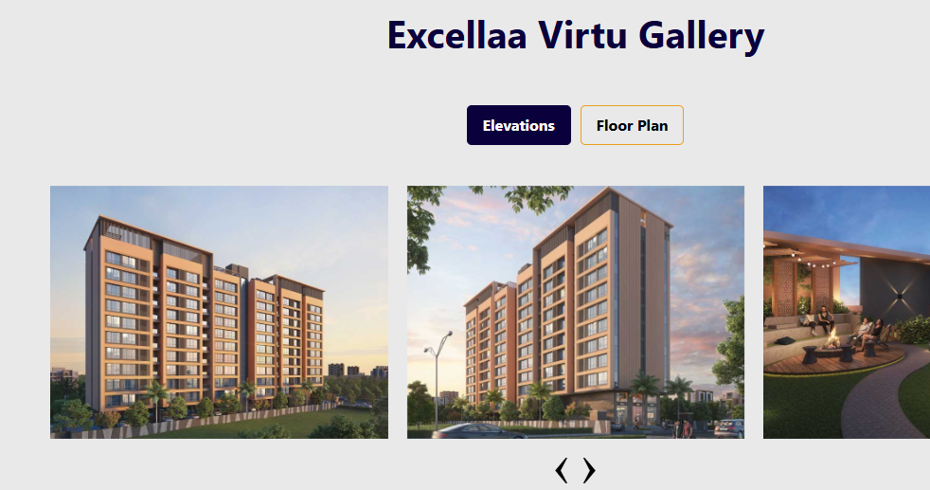

Before disclaimer, put small logo of project and below that full address with location pin:

Karjat Road, Kharwai Badlapur(e) Mumbai 421503.

Amenities section can be like this:

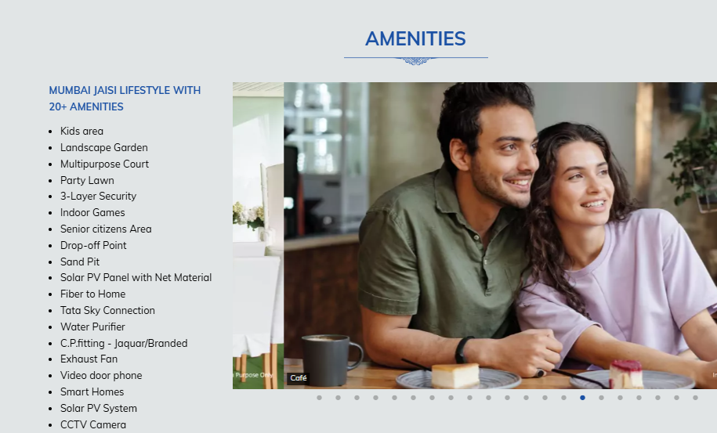

<https://agamiinfinitypark.com/>

Highlights can also be similar to the above: